DOCKER
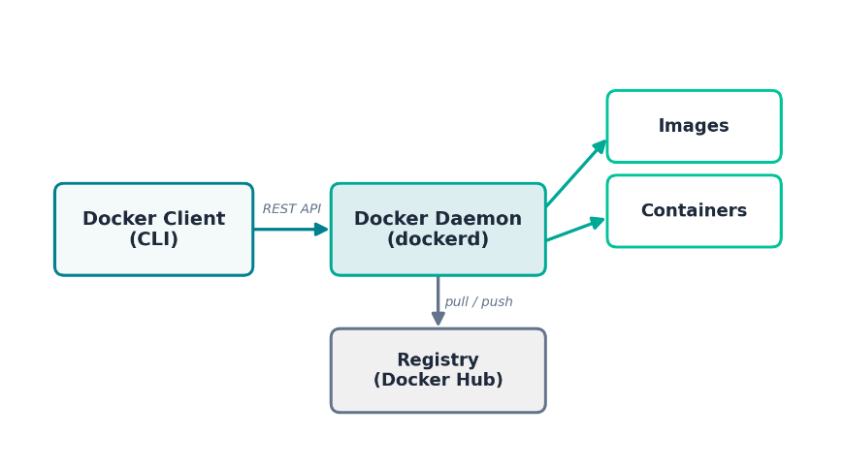
Contents
1. Introduction to Docker
2. Containers vs Virtual Machines
3. Docker Installation
4. Docker Architecture
5. Docker Hub
6. Docker Basic Commands
7. Creating Our First Image
8. Working with Multiple Images
9. Packaging a Customized Container
10. Running Container Commands with Docker
11. Managing and Removing Base Images
12. Pushing to Docker Hub
13. Create Own Images
14. Creating Own Dockerfiles
15. Docker Events
16. Docker Networking
17. Dockerfile for User
18. Docker Link
19. Docker Compose

1. Introduction to Docker
Docker is a platform that packages an application together with everything it needs to run — code, runtime, system libraries, and configuration — into a single, portable unit called a container. That container runs the same way on a developer's laptop, a teammate's machine, a test server, or in production.
Before Docker, teams constantly ran into the classic problem: "it works on my machine." Differences in OS versions, installed libraries, and configuration between environments caused applications to behave inconsistently. Docker solves this by shipping the application and its entire runtime environment together as one unit.
Why Teams Adopt Docker
• Consistency — the same image runs identically everywhere
• Speed — containers start in seconds, not minutes
• Isolation — each container has its own filesystem and process space
• Efficiency — many containers can share one host OS kernel
• Portability — build once, run on any machine with Docker installed

Key Vocabulary
- Image — a read-only template used to create containers (a blueprint)
- Container — a running (or stopped) instance created from an image
- Dockerfile — a text file of instructions used to build an image
- Registry — a place to store and share images (e.g., Docker Hub)
- Volume — persistent storage that outlives a single container

HANDS-ON EXAMPLE
Once Docker is installed (see Section 3), confirm it works by running the official test image:
docker run hello-world
Docker downloads a tiny test image and runs it inside a container. If you see a "Hello from Docker!" message, your engine is working correctly.

2. Containers vs Virtual Machines
Virtual machines (VMs) virtualize an entire computer, including a full guest operating system, on top of a hypervisor. Each VM is heavy (often several gigabytes) and can take minutes to boot.
Containers, on the other hand, share the host machine's OS kernel and isolate only the application layer using Linux namespaces and cgroups. This makes containers lightweight (often just megabytes) and able to start in a second or two.
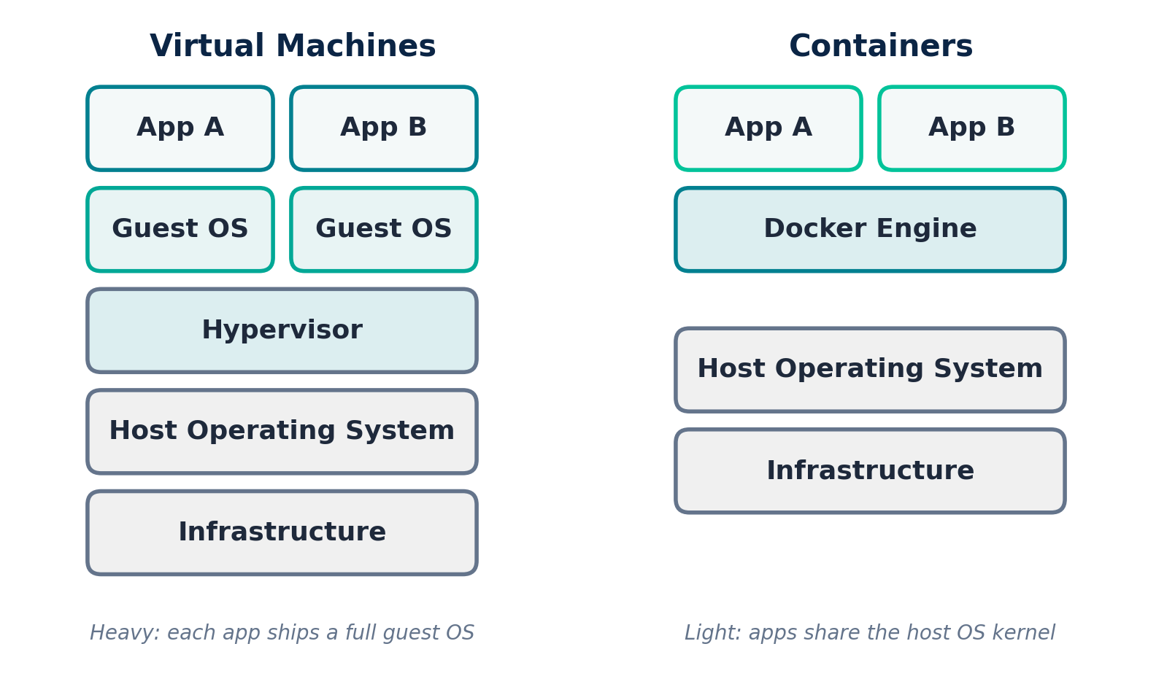
Figure 1 — Virtual Machines vs Containers

Comparison Table
Feature | Virtual Machines | Containers
Boot time | Minutes | Seconds
Typical size | Gigabytes | Megabytes
OS | Full guest OS per VM | Shares host OS kernel
Isolation | Strong (hardware-level) | Process-level (namespaces/cgroups)
Best for | Running different OS types | Consistent, fast-moving app environments
HANDS-ON EXAMPLE
See how lightweight a container is compared to spinning up a VM — this Alpine Linux container starts almost instantly:
docker run --rm alpine echo "Hello from a container!"

docker run: instruct the docker engine to create and start a new container

--rm: removes the container from the host file system once it exits.

3. Docker Installation
Docker Engine can be installed on Linux, Windows, and macOS. On Linux servers you typically install Docker Engine directly; on Windows/Mac, Docker Desktop bundles the engine, CLI, and Compose together, running a lightweight Linux VM under the hood.
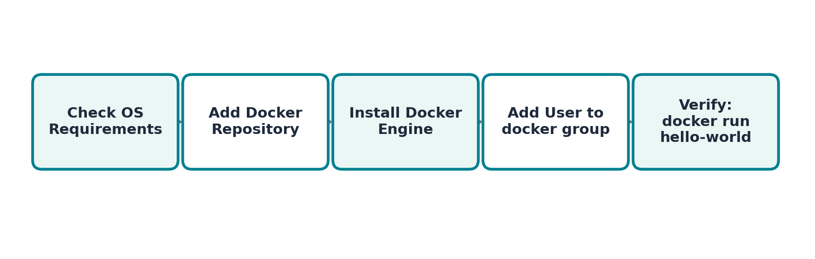
Figure 2 — Installation Steps (Linux)

Installing on Ubuntu / Debian-based Linux
HANDS-ON EXAMPLE
# 1. Update package index and install prerequisites
sudo apt-get update
sudo apt-get install -y ca-certificates curl gnupg

Website: https://docs.docker.com/engine/install/ubuntu/#install-using-the-repository

# 2. Add Docker's official GPG key:
sudo apt update
sudo apt install ca-certificates curl
sudo install -m 0755 -d /etc/apt/keyrings
sudo curl -fsSL https://download.docker.com/linux/ubuntu/gpg -o /etc/apt/keyrings/docker.asc
sudo chmod a+r /etc/apt/keyrings/docker.asc

# 3. Add the repository to Apt sources:
sudo tee /etc/apt/sources.list.d/docker.sources <<EOF
Types: deb
URIs: https://download.docker.com/linux/ubuntu
Suites: $(. /etc/os-release && echo "${UBUNTU_CODENAME:-$VERSION_CODENAME}")
Components: stable
Architectures: $(dpkg --print-architecture)
Signed-By: /etc/apt/keyrings/docker.asc
EOF

sudo apt update

4. Install the Docker packages
sudo apt install docker-ce docker-ce-cli containerd.io docker-buildx-plugin docker-compose-plugin

sudo systemctl status docker

sudo systemctl start docker

Test: Run command -- sudo docker run hello-world

Installing on Windows and macOS
Download and install Docker Desktop from docker.com. It includes the Docker Engine, CLI, and Docker Compose in one package, and provides a simple GUI for managing containers, images, and settings.

Verifying the Installation
HANDS-ON EXAMPLE
docker –version
docker run hello-world

If installation succeeded, Docker pulls a small test image and prints a confirmation message. If you get a permissions error on Linux, make sure you've logged out and back in (or run "newgrp docker") after adding your user to the docker group.

4. Docker Architecture
Docker uses a client-server architecture. The Docker Client is the command-line tool you type commands into. It talks to the Docker Daemon (dockerd) over a REST API. The daemon does the real work: building images, running containers, and managing networks and volumes. It also pulls and pushes images to and from a Registry, such as Docker Hub.
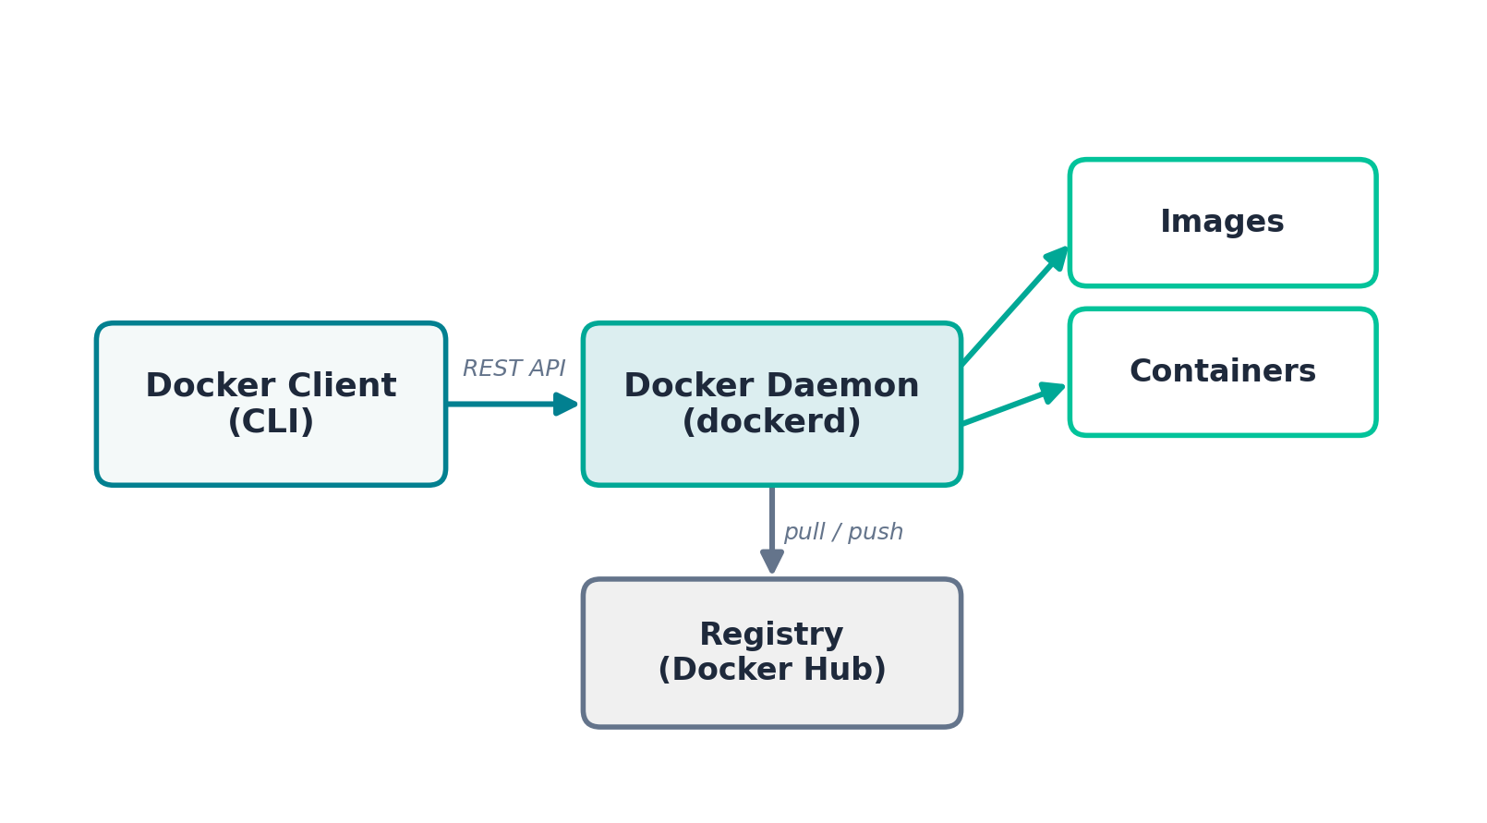
Figure 2 — Docker's Client-Server Architecture

Components
- Docker Client — the docker CLI you run in your terminal
- Docker Daemon (dockerd) — runs in the background, manages Docker objects
- Docker Registry — stores and distributes images (Docker Hub is the default)
- Docker Objects — images, containers, networks, and volumes

HANDS-ON EXAMPLE
Inspect your own Docker setup and confirm the client-server relationship:
docker version
docker info
The output of "docker version" shows separate Client and Server sections, confirming that the CLI and the daemon are two different components communicating over an API.

5. Docker Hub
Docker Hub (hub.docker.com) is the default public registry for Docker images. It hosts official images maintained by software vendors (nginx, mysql, node, python, etc.), community images, and your own public or private repositories.
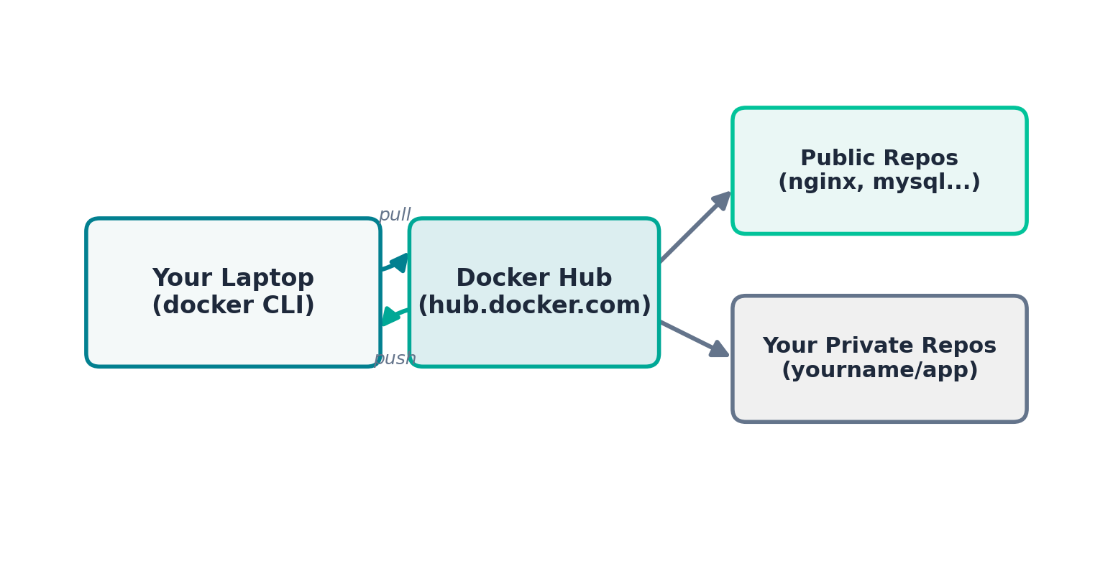
Figure 3 — Local Machine, Docker Hub, and Repositories

Finding and Pulling Images
HANDS-ON EXAMPLE
# Search Docker Hub from the CLI
docker search nginx

# Pull the official nginx image
docker pull nginx

# Pull a specific tag/version
docker pull nginx:1.25-alpine
You can also browse hub.docker.com in a browser to read an image's documentation, see available tags, and check when it was last updated — always prefer official images or images with high download counts and recent updates for production use.
Good Habits on Docker Hub
• Prefer "Official Image" or "Verified Publisher" badges
• Always pin a specific tag/version instead of :latest in production
• Check the Dockerfile source link when available, to see what's inside

6. Docker Basic Commands
Once Docker is installed, these commands form the foundation of daily work: pulling images, running containers, and inspecting what's happening on your machine.
docker run -d -p 8080:80 --name my-web-app nginx -- it will create container and run the app in 8080 port

Image Commands
Command | Purpose
docker pull <image> | Download an image from a registry (docker hub)
docker images | List images stored locally
docker rmi <image> | Remove a local image
docker build -t name . | Build an image from a Dockerfile

Container Commands
Command | Purpose
docker run <image> | Create and start a container
docker run -d <image> | Run in detached (background) mode
docker run -it <image> bash | Run interactively with a terminal
docker ps | List running containers
docker ps -a | List all containers, including stopped
docker stop <container> | Stop a running container
docker start <container> | Start a stopped container
docker rm <container> | Remove a container
docker logs <container> | View container logs
docker exec -it <container> bash | Open a shell inside a running container
HANDS-ON EXAMPLE
# Run an interactive Ubuntu container
docker run -it ubuntu bash
cat /etc/os-release
exit

# Run Nginx in the background, mapping host port 8080
docker run -d --name webserver -p 8080:80 nginx
docker ps
docker logs webserver

# Open a shell inside the running container
docker exec -it webserver bash
ls /usr/share/nginx/html
exit
Visit http://localhost:8080 in a browser — you should see the Nginx welcome page, served from inside the container.

docker cp path/index.html container_name:/usr/share/nginx/html/index.html

7. Creating Our First Image
A Dockerfile describes, step by step, how to build an image. Running "docker build" turns those instructions into an image; "docker run" then starts a container from it.
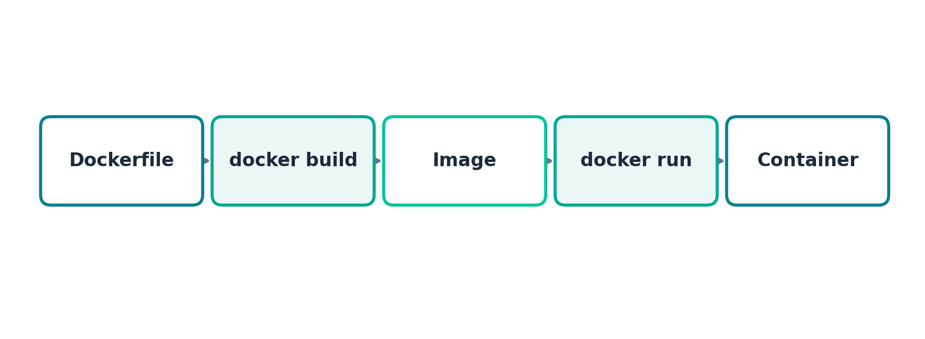
Figure 5 — From Dockerfile to Running Container

Example: A Simple Node.js Web App
Project files — app.js:
const http = require('http');
const server = http.createServer((req, res) => {
res.end('Hello from my first Docker image!\n');
});
server.listen(3000, () => console.log('Listening on 3000'));

package.json:
{
"name": "first-image",
"version": "1.0.0",
"main": "app.js",
"scripts": { "start": "node app.js" }
}

Dockerfile:
FROM node:18-alpine
WORKDIR /app
COPY package.json .
RUN npm install
COPY . .
EXPOSE 3000
CMD ["npm", "start"]
HANDS-ON EXAMPLE
# Build the image (the "." means: Dockerfile is in this folder)
docker build -t first-image:1.0 .

# Run a container from it
docker run -d -p 3000:3000 --name my-first-app first-image:1.0

# Test it
curl http://localhost:3000

Docker caches each instruction as a layer. Because we copy package.json and run npm install before copying the rest of the code, editing app.js later won't force a slow reinstall of dependencies on rebuild — Docker reuses the cached layer.

8. Working with Multiple Images
A single Docker host can store many images and run many containers side by side, each fully isolated from the others — for example, a web server, a database, and an application runtime all running at once.

Why Use Multiple Images?
Enterprise applications are usually built using multiple services rather than one large application.
For example, an e-commerce application may consist of: Customer Browser >> Nginx Web Server >> Spring Boot API >> MySQL Database
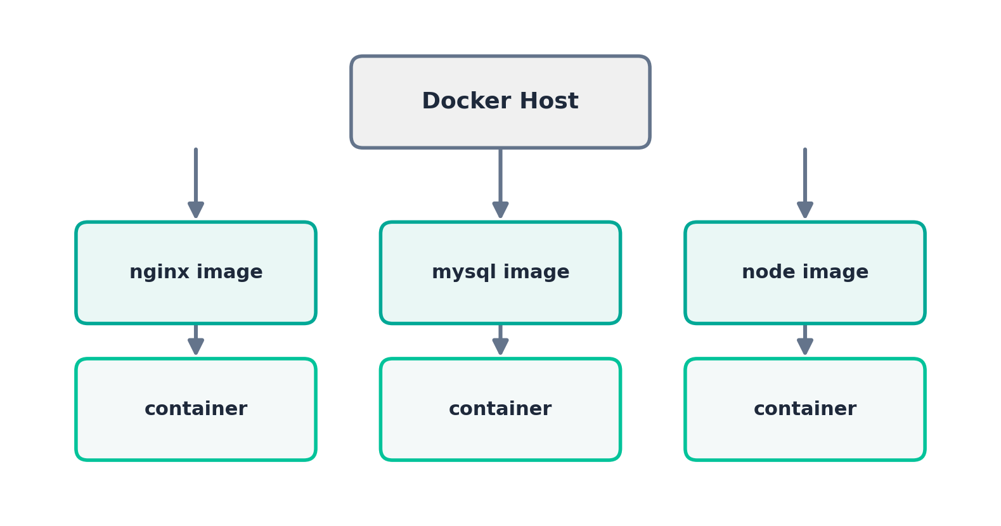
Figure 6 — Multiple Images Running as Separate Containers
HANDS-ON EXAMPLE
# Pull three different images
docker pull nginx
docker pull mysql:8
docker pull node:18-alpine

# Run a container from each, on different host ports
docker run -d --name web -p 8080:80 nginx
Login by using ip:8080

docker run -d --name database -e MYSQL_ROOT_PASSWORD=pass -p 3306:3306 mysql:8

docker run -d --name app -p 3000:3000 first-image:1.0

# See all images and all running containers
docker images
docker ps

# Demonstrate Filesystem Isolation
docker exec -it web /bin/sh or sh or bash
touch demo.txt
exit -- login to nodejs container and check if demo.txt exists. it will not exists, because each container has it’s own file system

Now check the MySQL container:

docker exec database ps -ef -- You'll see only MySQL-related processes.
docker exec -it database mysql -u root -p to login database
Each container has its own filesystem, network namespace, and process list — installing something inside "web" has no effect on "database" or "app", even though they're all running on the same physical or virtual machine.

Container Isolation
Although containers share the host's Linux kernel, Docker isolates them in several ways:
- Filesystem isolation: Files created inside one container are not visible in another.
- Process isolation: Each container has its own process list.
- Network isolation: Containers communicate through Docker networking instead of sharing the host network directly.
- Environment isolation: Environment variables are scoped to the individual container.
This isolation is implemented using Linux namespaces and cgroups.

9. Packaging a Customized Container
Sometimes it's useful to start from an existing container, customize it interactively, and then save your changes as a brand-new image. This is done with "docker commit" — a quick way to snapshot a container's current filesystem into an image (Dockerfiles are still the recommended approach for anything you'll maintain long-term, covered in Section 14).
HANDS-ON EXAMPLE
# Start a plain Ubuntu container interactively
docker run -it --name customized-ubuntu ubuntu bash

# Inside the container, install some tools
apt-get update && apt-get install -y curl vim git
exit

# Commit the customized container into a new image
docker commit customized-ubuntu myteam/ubuntu-with-tools:1.0

# Confirm the new image exists and run a container from it
docker images
docker run -it myteam/ubuntu-with-tools:1.0 bash
curl –version
docker commit vs Dockerfile
• docker commit — quick, manual, good for one-off experiments
• Dockerfile — repeatable, version-controlled, reviewable — always prefer this for anything shared with a team

10. Running Container Commands with Docker
Containers move through a predictable lifecycle: created, running, optionally paused, stopped, and eventually removed. Knowing the commands for each state is core to daily Docker work.
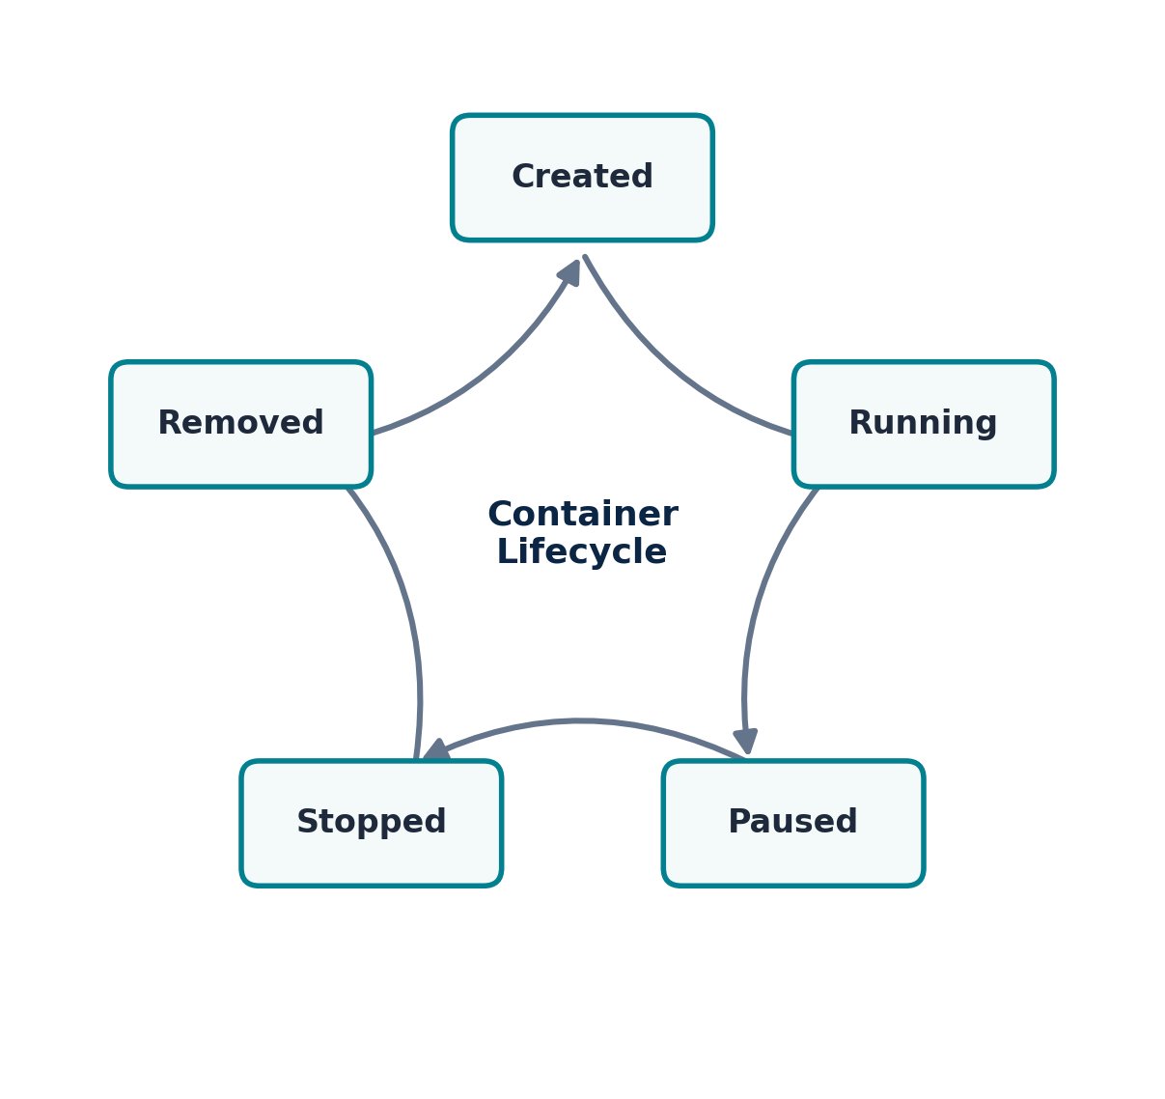
Figure 7 — The Container Lifecycle
Command | Purpose
docker create <image> | Create a container without starting it
docker start <container> | Start a created or stopped container
docker pause <container> | Freeze all processes in a container
docker unpause <container> | Resume a paused container
docker stop <container> | Gracefully stop a running container
docker kill <container> | Force-stop a container immediately
docker restart <container> | Restart a container
docker rm <container> | Remove a stopped container
docker rm -f <container> | Force remove a running container
HANDS-ON EXAMPLE
docker create --name demo nginx
docker start demo
docker pause demo
docker unpause demo
docker stop demo
docker restart demo
docker rm -f demo

exec vs attach
"docker exec" runs a brand-new process inside a running container (most common — used to open a shell or run a one-off command). "docker attach" instead connects your terminal directly to the container's main process (PID 1) — useful for watching its live output, but risky, since pressing Ctrl+C can stop that main process.
docker exec -it demo sh # new shell process
docker attach demo # attach to the main process

11. Managing and Removing Base Images
Over time, a development machine accumulates unused images, stopped containers, and dangling layers. Docker provides commands to inspect, tag, and clean these up.

Inspecting Images
docker images # list all local images
docker image inspect nginx # detailed JSON metadata
docker history nginx # show each layer in the image

Tagging and Removing
HANDS-ON EXAMPLE
# Tag an image with a new name/version
docker tag nginx:latest myteam/nginx:v1

# Remove a specific image
docker rmi myteam/nginx:v1

# Remove an image even if a stopped container references it
docker rmi -f nginx

# Remove ALL unused images, containers, and networks
docker system prune -a

# Remove only dangling (untagged) images
docker image prune
Before You Prune
• docker system prune -a is aggressive — it removes every image not used by a running container
• Always double-check docker ps -a first so you don't lose a container you still need

12. Pushing to Docker Hub
Once you've built your own image, you can share it by pushing it to a registry such as Docker Hub, so teammates (or production servers) can pull and run it.
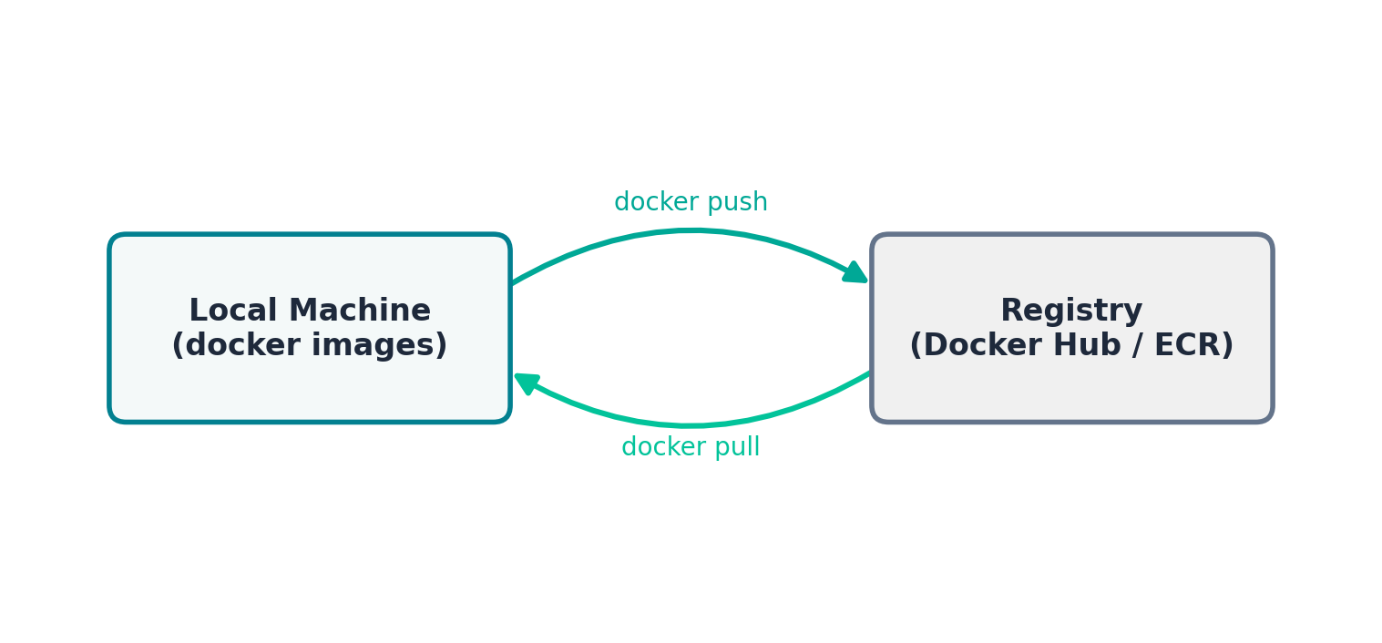
Figure 8 — Pushing and Pulling Images from a Registry
HANDS-ON EXAMPLE
# Log in to Docker Hub (creates ~/.docker/config.json)
docker login

# Tag your local image with your Docker Hub username
docker tag first-image:1.0 yourusername/first-image:1.0

# Push it to Docker Hub
docker push yourusername/first-image:1.0

# Anyone can now pull it
docker pull yourusername/first-image:1.0
Image names follow the pattern registry/username/repository:tag. When no registry host is given, Docker assumes Docker Hub. For a private registry you'd instead tag it as myregistry.example.com/username/repo:tag.

13. Create Own Images
There are two common ways to create your own image: interactively customizing a container and committing it (Section 9), or — the recommended approach — writing a Dockerfile that describes the build reproducibly (Section 14). This section ties the two approaches together with a second, complete example.
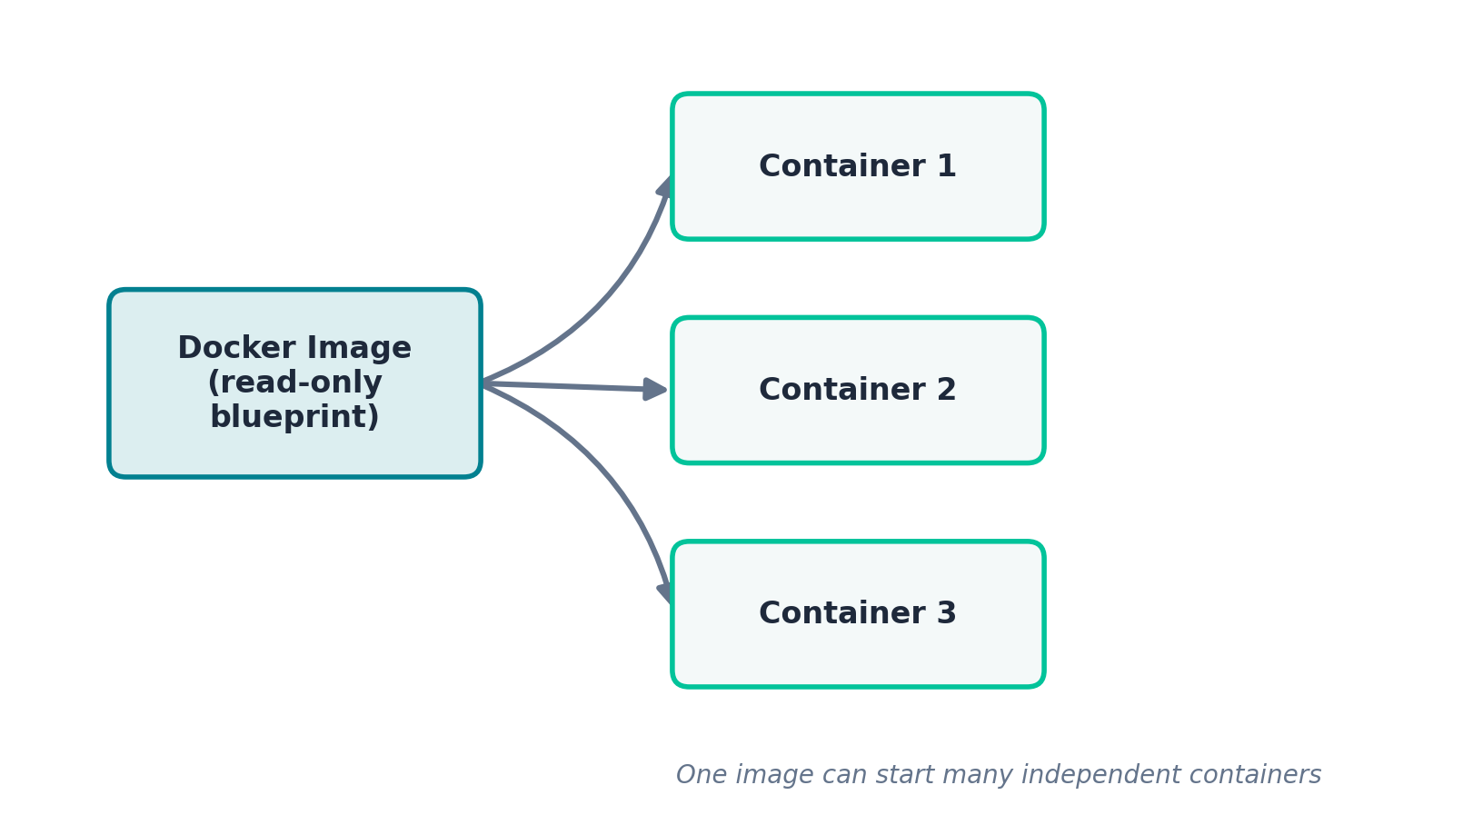
Figure 9 — One Image Can Produce Many Containers

Example: A Python Flask App Image
app.py:
from flask import Flask
app = Flask(__name__)

@app.route('/')
def home():
return 'Hello from my own custom image!'

if __name__ == '__main__':
app.run(host='0.0.0.0', port=5000)
requirements.txt:
flask==3.0.0
Dockerfile:
FROM python:3.11-slim
WORKDIR /app
COPY requirements.txt .
RUN pip install --no-cache-dir -r requirements.txt
COPY . .
EXPOSE 5000
CMD ["python", "app.py"]
HANDS-ON EXAMPLE
docker build -t flask-demo:1.0 .
docker run -d -p 5000:5000 --name flask-app flask-demo:1.0
curl http://localhost:5000

14. Creating Own Dockerfiles
Dockerfiles support a specific set of instructions. Understanding each one lets you write clear, efficient, and secure images.
Instruction | Purpose
FROM | Base image to build from
WORKDIR | Sets the working directory inside the image
COPY / ADD | Copies files from host into the image
RUN | Executes a command at build time (installs packages, etc.)
ENV | Sets an environment variable
ARG | Defines a build-time variable
EXPOSE | Documents which port the container listens on
VOLUME | Declares a mount point for persistent data
USER | Sets the user the container runs as (see Section 17)
CMD | Default command run when the container starts
ENTRYPOINT | Configures the container as a fixed executable

Annotated Example
FROM node:18-alpine
LABEL maintainer="devops-team@example.com"

WORKDIR /app

# Copy dependency manifests first — better layer caching
COPY package*.json ./
RUN npm ci --omit=dev

# Now copy the rest of the source code
COPY . .

ENV NODE_ENV=production
EXPOSE 3000

CMD ["node", "app.js"]

CMD vs ENTRYPOINT
CMD provides default arguments that can be fully overridden at "docker run" time. ENTRYPOINT fixes the executable, and any CMD becomes its default arguments.
# CMD form — easily overridden
CMD ["npm", "start"]
docker run myimage echo hi # replaces the CMD entirely

# ENTRYPOINT form — fixed executable, CMD supplies default args
ENTRYPOINT ["node"]
CMD ["app.js"]
docker run myimage other.js # runs: node other.js

.dockerignore
Just like .gitignore, a .dockerignore file excludes files from the build context, keeping builds fast and images small:
node_modules
.git
*.log
.env
Dockerfile
.dockerignore

15. Docker Events
The Docker daemon emits a real-time stream of events whenever something happens: a container is created, started, stopped, or removed; an image is pulled; a network is connected; and more. The "docker events" command lets you watch this stream live — extremely useful for debugging and for building automation that reacts to container lifecycle changes.
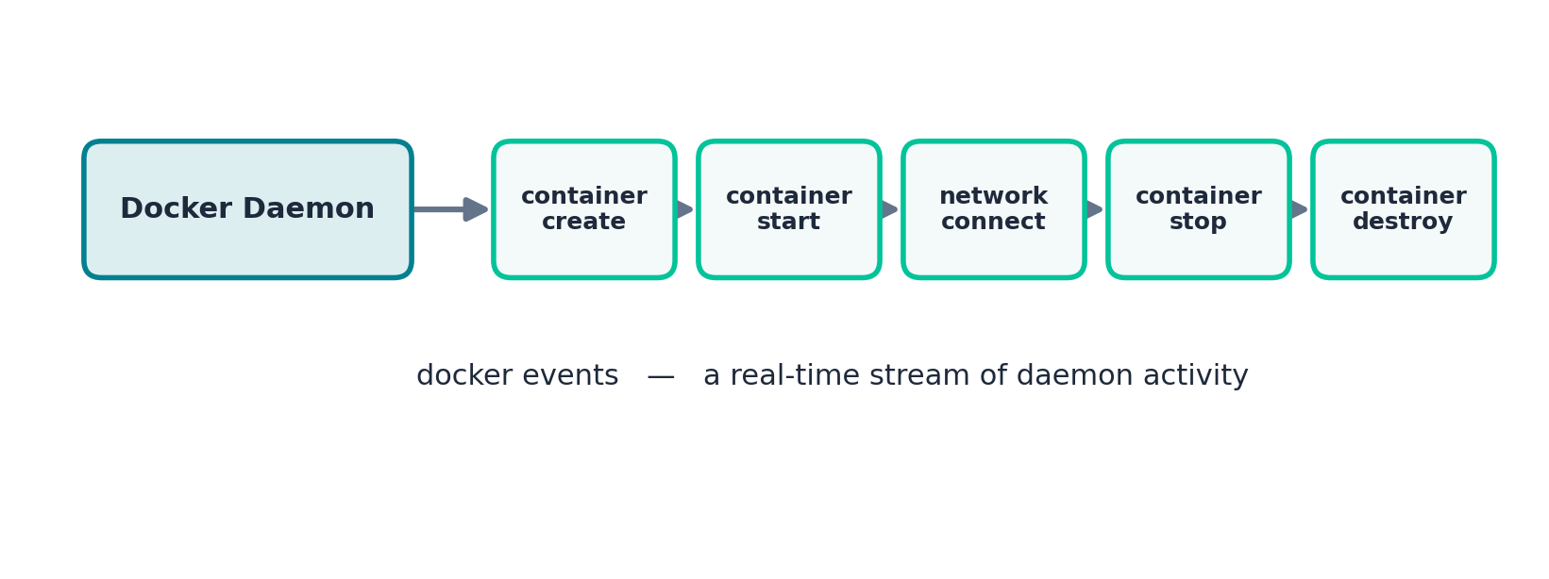
Figure 10 — A Stream of Real-Time Daemon Events
HANDS-ON EXAMPLE
# Watch all events live (leave this running in one terminal)
docker events

# In another terminal, trigger some events
docker run -d --name event-demo nginx
docker stop event-demo
docker rm event-demo
You'll see a stream like "container create", "container start", "container die", "container stop", and "container destroy" scroll by, each tagged with the container ID and a timestamp.

Filtering Events
# Only show container-related events
docker events --filter 'type=container'

# Only events for one specific container
docker events --filter 'container=event-demo'

# Only events since a certain time
docker events --since '2026-07-01'

16. Docker Networking
Docker automatically sets up networking for containers, but understanding the network types helps when multiple containers need to talk to each other.
Network Type | Description
bridge (default) | Private internal network; containers on the same custom bridge can reach each other by name
host | Container shares the host's network stack directly, with no isolation
none | No networking at all
overlay | Used in Docker Swarm for multi-host networking
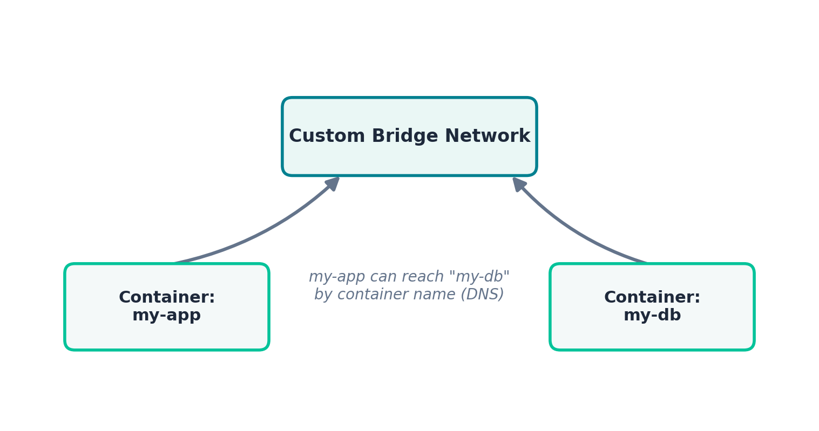
Figure 11 — Containers Communicating on a Custom Bridge Network
HANDS-ON EXAMPLE
# Create a custom bridge network
docker network create my-network

# Run a database container on it
docker run -d --name my-db --network my-network \
-e MYSQL_ROOT_PASSWORD=pass mysql:8

# Run an app container on the SAME network
docker run -d --name my-app --network my-network first-image:1.0

# From inside my-app, reach my-db simply by container name
docker exec -it my-app sh
ping my-db
This works because Docker's embedded DNS resolves container names to their internal IP addresses — but only for containers on the same custom network. This is exactly the mechanism Docker Compose relies on.
docker network ls # list all networks
docker network inspect my-network # see connected containers & IPs

17. Dockerfile for User
By default, processes inside a container run as root. This is convenient but risky: if an attacker breaks out of the application, they land with root privileges inside the container (and potentially beyond it). The USER instruction lets you create and switch to a non-root user in your Dockerfile, following the principle of least privilege.
HANDS-ON EXAMPLE
FROM node:18-alpine
WORKDIR /app

COPY package*.json ./
RUN npm ci --omit=dev
COPY . .

# Create a dedicated non-root group and user
RUN addgroup -S appgroup && adduser -S appuser -G appgroup

# Make sure the new user owns the app files
RUN chown -R appuser:appgroup /app

# Switch to the non-root user for everything from here on
USER appuser

EXPOSE 3000
CMD ["node", "app.js"]
Build and confirm the container is not running as root:
docker build -t secure-app:1.0 .
docker run -d --name secure-container -p 3000:3000 secure-app:1.0
docker exec secure-container whoami
# -> appuser (not root)
Why This Matters
• Limits the damage an attacker can do if the application is compromised
• Many container security scanners flag images that run as root
• Some Kubernetes clusters enforce non-root containers by policy

18. Docker Link
Before user-defined networks existed, Docker offered the --link flag to connect two containers and let one reach the other by name. It's a legacy feature that still works but is officially deprecated — custom bridge networks (Section 16) are the modern replacement and should be used for all new work.
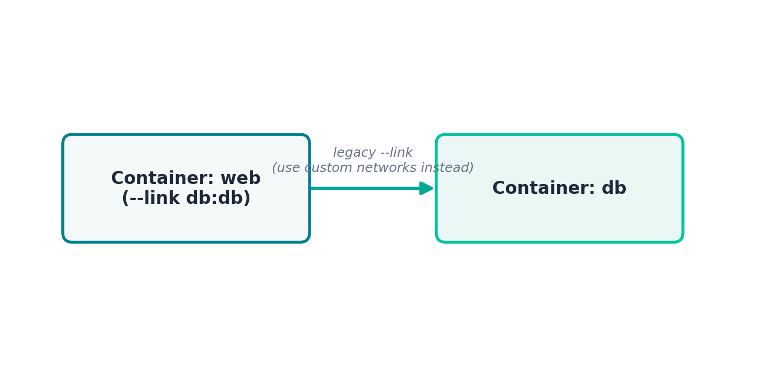
Figure 12 — The Legacy --link Flag
HANDS-ON EXAMPLE
# Legacy approach (for reference only)
docker run -d --name db mysql:8 -e MYSQL_ROOT_PASSWORD=pass
docker run -d --name web --link db:db first-image:1.0

# Inside "web", the host "db" now resolves to the db container
docker exec -it web sh
ping db
Why --link is Deprecated
• Only works one-directional and only between containers on the default bridge network
• Doesn't support automatic DNS resolution the way custom networks do
• Docker's own documentation recommends migrating to user-defined networks
Prefer this instead: create a custom network (docker network create) and attach both containers to it with --network, as shown in Section 16 — no --link required, and it also works seamlessly with Docker Compose.

19. Docker Compose
Real applications usually need multiple services running together — an app, a database, maybe a cache. Docker Compose lets you define an entire multi-container application in a single YAML file, and bring it all up with one command.
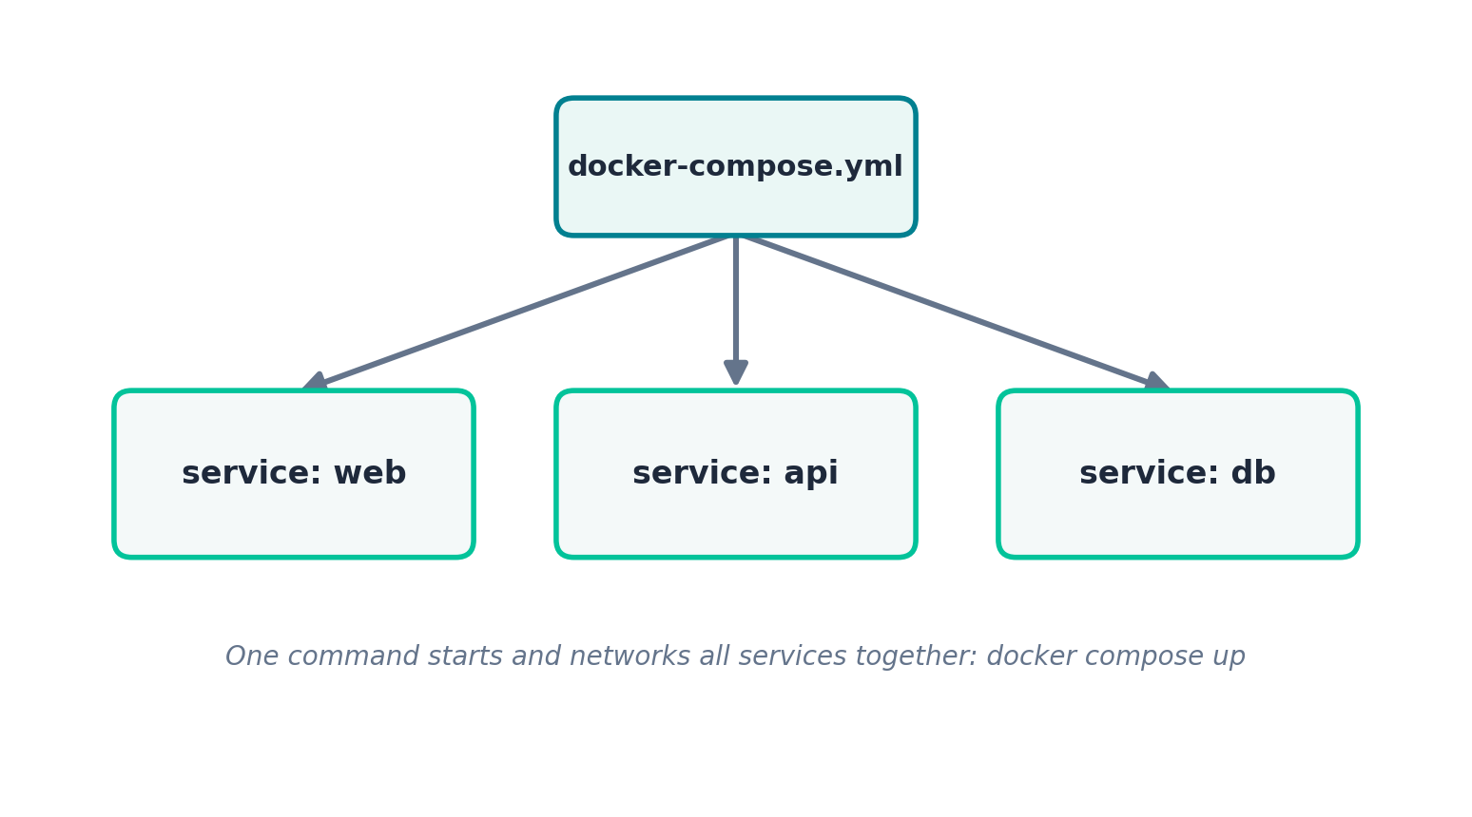
Figure 13 — A Compose File Orchestrating Multiple Services

Example: Node.js App + MongoDB
docker-compose.yml:
version: "3.9"

services:
web:
build: .
ports:
- "3000:3000"
environment:
- MONGO_URL=mongodb://mongo:27017/mydb
depends_on:
- mongo
networks:
- app-network

mongo:
image: mongo:6
volumes:
- mongo-data:/data/db
networks:
- app-network

volumes:
mongo-data:

networks:
app-network:
HANDS-ON EXAMPLE
docker compose up -d # build & start every service
docker compose ps # list running services
docker compose logs -f # follow logs from all services
docker compose exec web sh # shell into the web service
docker compose down # stop and remove containers/networks
docker compose down -v # also remove volumes (deletes data!)
Notice that inside the web container, the database is reachable simply as "mongo" — Compose automatically creates a shared network and registers each service's name in DNS, exactly like the custom bridge network in Section 16.
Compose Cheat Sheet
• docker compose up --build — rebuild images before starting
• docker compose up -d --scale web=3 — run 3 instances of one service
• docker compose stop / start — stop or start without removing containers

End of Notes — practice each hands-on example before moving to the next topic.

